Geometry: Unit 11, Lesson 6

- Is the inequality $12.5+17.3>29$ true?

Yes

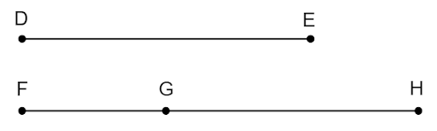
- Line segments $DE$ and $FH$ are shown. Point $G$ lies on $\overline{FH}$. $DE=8$, $FG=4$, and $GH=7$. What is equal to $FG+GH$?

$$FH$$

- The values $17.2$ and $31.8$ are used in the three inequalities shown. What value is a solution to all three inequalities?
$31.8+x>17.2$ $31.8+17.2>x$ $17.2+x>31.8$

$$x=20.7$$

